Goal of the Exercise
The goal of this exercise is to test your understanding of a Cloud Compute deployment with Terraform.
You are tasked with creating a codebase for a microservice deployment on a cloud environment, using Terraform. Since our focus is not the application itself, the service will be a simple web server that returns a static page.
Requirements
Service Details
The service will be a simple web server that returns a static page.
You can use apache2 or nginx to serve a simple HTML file.
The service should be containerized and stored in a Docker registry.
The service should be deployed on a single VM instance as a docker container.
The image should be pulled from the registry specified earlier.
- The service should not be accessible from the internet but only through a Load Balancer, except for SSH access from specific IP addresses.
Deliverables
You are to provide the following as part of your solution:
- Dockerfile to build the image.
Terraform codebase to deploy the following:
- Docker registry
- VPC and all required networking resources
- EC2 instance
- Load Balancer
Notes
Since a CI/CD pipeline is not part of this exercise, we will work around that with the help of Terraform.
To push the image to the Docker registry, build the image locally before running the Terraform code.
Once the image registry is created, use Terraform to push the local image to the registry.
Similarly, use Terraform to pull the image from the registry and run it on the VM instance once it is created.
For SSH access:
- Use a locally created key.
- Add it to the cloud provider key storage.
Attach it to the instance.
Use Terraform best practices for file structure and code organization.
Use variables, locals, modules, etc. when appropriate.
Include all tfvars, scripts, and other helper files used to deploy the application.
You may use any cloud provider of your choosing, although AWS is preferred.
- Use a free tier account or a trial account to deploy the resources.

PROJECT FLOW
- Create project structure
- Create simple web app (HTML)
- Create Docker image
- Push image to AWS ECR
- Write Terraform code:
  - VPC + Networking
  - Security Groups
  - EC2
  - Load Balancer
  - ECR
- Deploy infra using Terraform
- Pull image & run container on EC2
- Access app via Load Balancer

STEP 1: Create Project Structure

mkdir terraform-microservice
cd terraform-microservice
mkdir app docker terraform scripts

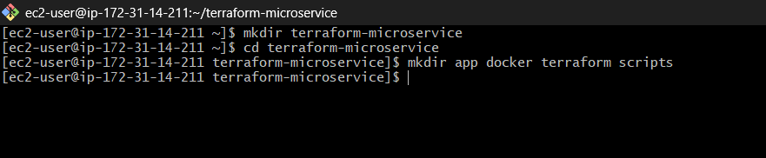

Final structure:
terraform-microservice/
│
├── app/
├── docker/
├── terraform/
├── scripts/

STEP 2: Create Simple Web App

Go inside app/:
cd app
Create index.html:
Vi index.html
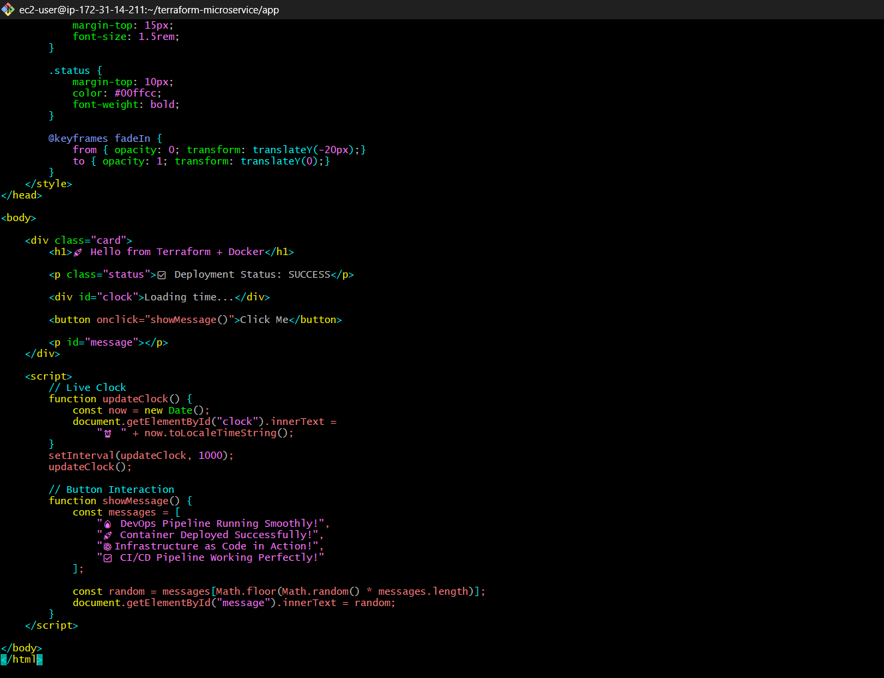

<!DOCTYPE html>
<html lang="en">
<head>
<meta charset="UTF-8">
<title>DevOps Challenge</title>
<style>
/* Reset */
* {
margin: 0;
padding: 0;
box-sizing: border-box;
font-family: 'Segoe UI', sans-serif;
}

body {
height: 100vh;
background: linear-gradient(270deg, #0f2027, #203a43, #2c5364);
background-size: 600% 600%;
animation: gradientBG 10s ease infinite;
color: white;
display: flex;
justify-content: center;
align-items: center;
flex-direction: column;
text-align: center;
}

@keyframes gradientBG {
0% { background-position: 0% 50%; }
50% { background-position: 100% 50%; }
100% { background-position: 0% 50%; }
}
h1 {
font-size: 3rem;
margin-bottom: 20px;
animation: fadeIn 2s ease-in-out;
}
.card {
background: rgba(255, 255, 255, 0.1);
padding: 30px;
border-radius: 15px;
backdrop-filter: blur(10px);
box-shadow: 0 8px 32px rgba(0,0,0,0.3);
}
button {
margin-top: 20px;
padding: 12px 25px;
border: none;
border-radius: 25px;
background: #00c6ff;
color: black;
font-weight: bold;
cursor: pointer;
transition: 0.3s;
}
button:hover {
background: #0072ff;
color: white;
transform: scale(1.1);
}
#clock {
margin-top: 15px;
font-size: 1.5rem;
}
.status {
margin-top: 10px;
color: #00ffcc;
font-weight: bold;
}
@keyframes fadeIn {
from { opacity: 0; transform: translateY(-20px);}
to { opacity: 1; transform: translateY(0);}
}
</style>
</head>
<body>
<div class="card">
<h1>🚀 Hello from Terraform + Docker</h1>
<p class="status">✅ Deployment Status: SUCCESS</p>
<div id="clock">Loading time...</div>
<button onclick="showMessage()">Click Me</button>
<p id="message"></p>
</div>
<script>
// Live Clock
function updateClock() {
const now = new Date();
document.getElementById("clock").innerText =
"⏰ " + now.toLocaleTimeString();
}
setInterval(updateClock, 1000);
updateClock();

// Button Interaction
function showMessage() {
const messages = [
"🔥 DevOps Pipeline Running Smoothly!",
"🚀 Container Deployed Successfully!",
"⚙️ Infrastructure as Code in Action!",
"✅ CI/CD Pipeline Working Perfectly!"
];
const random = messages[Math.floor(Math.random() * messages.length)];
document.getElementById("message").innerText = random;
}
</script>
</body>
</html>
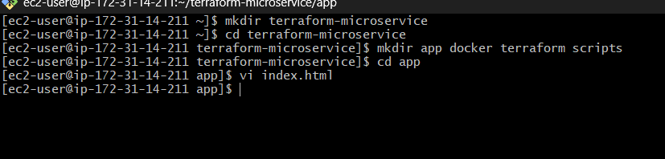
This is what your container will serve.
STEP 3: Create Dockerfile
Vi Dockerfile
FROM nginx:latest
COPY index.html /usr/share/nginx/html/index.html
EXPOSE 80
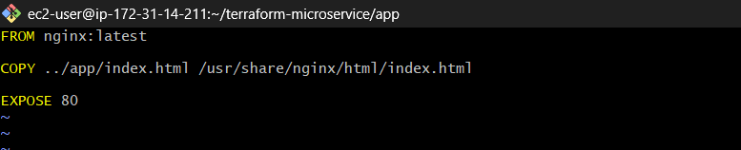
STEP 4: Build Docker Image
docker build -t myapp:latest .
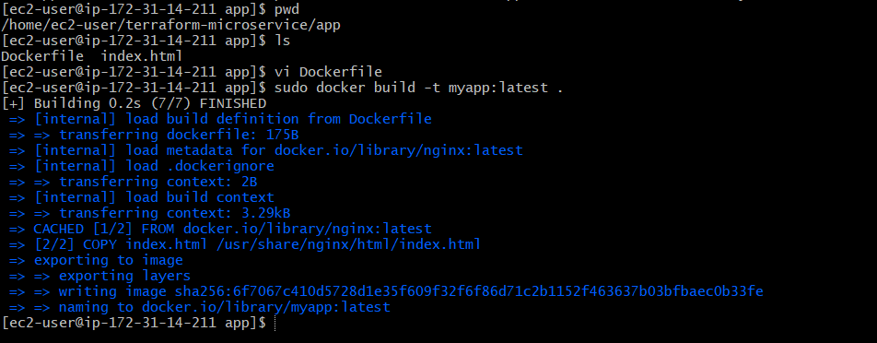
Test locally:
docker run -d -p 8080:80 myapp
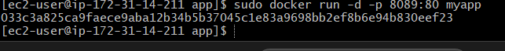
Open: http:// 16.16.98.228:80
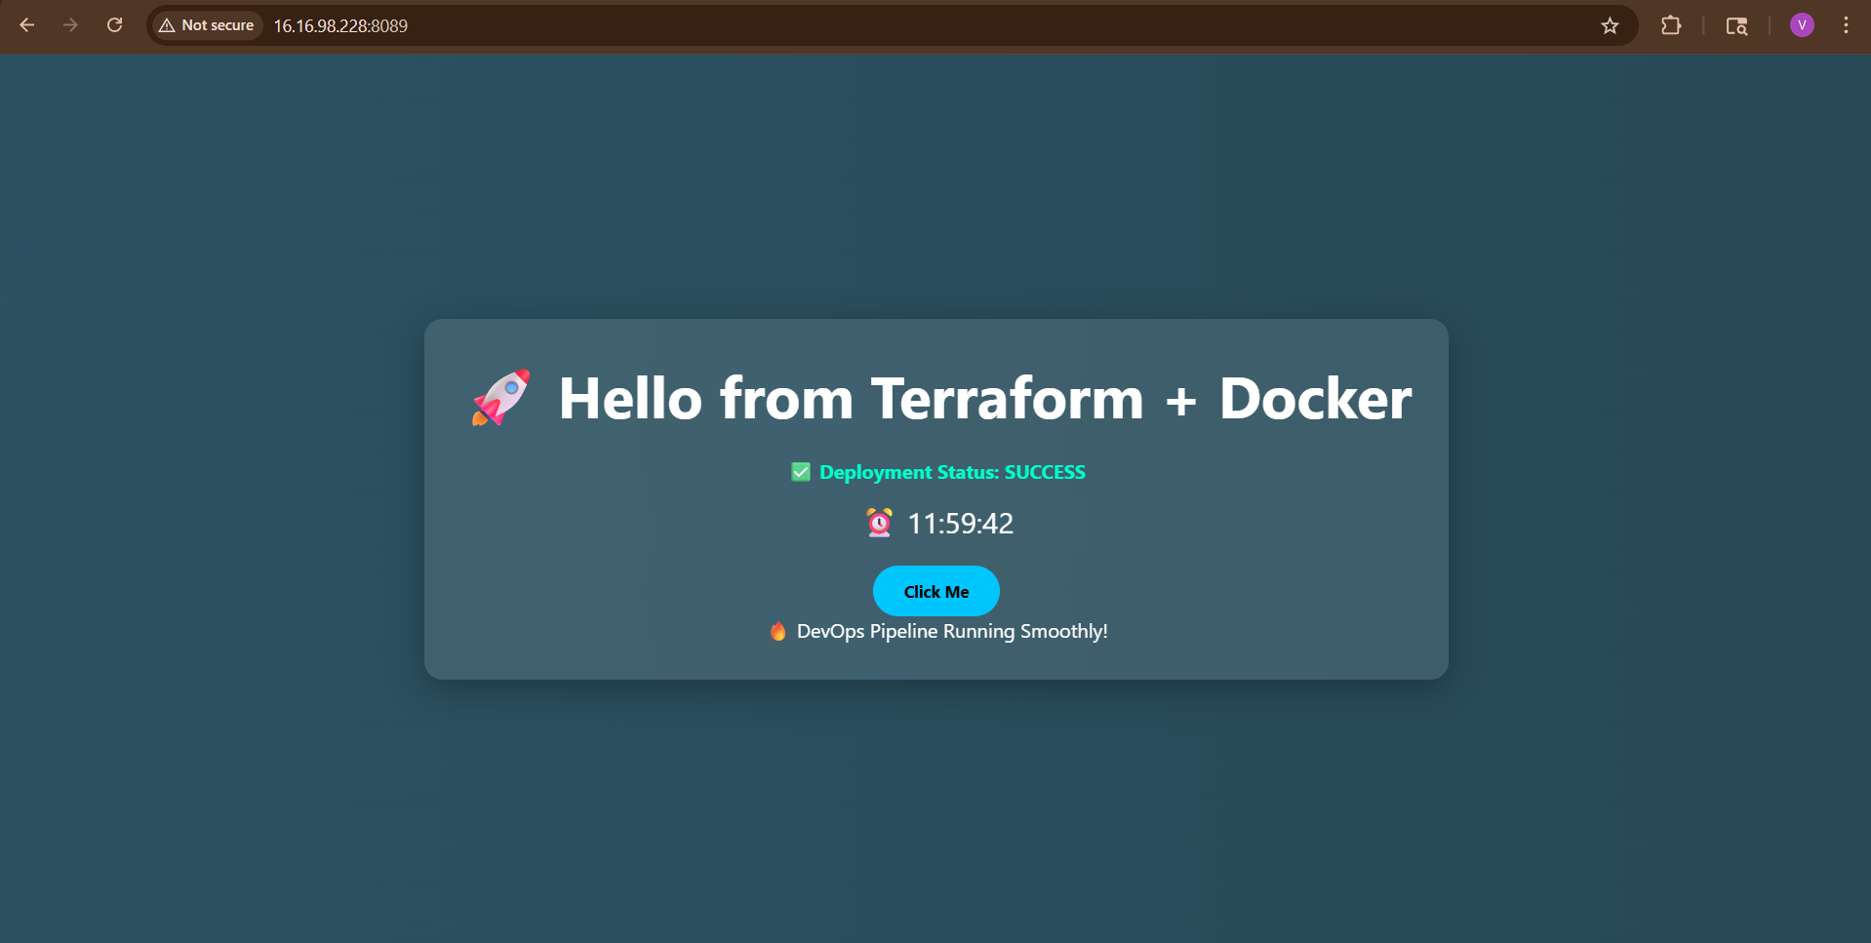

STEP 5: Terraform Setup
Go to terraform folder:
cd ../terraform

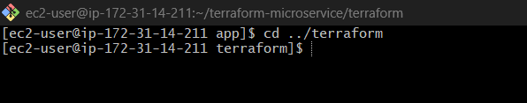

Create Files
terraform/
│
├── main.tf
├── variables.tf
├── outputs.tf
├── provider.tf
├── terraform.tfvars

Now create files:
touch main.tf variables.tf outputs.tf provider.tf terraform.tfvars
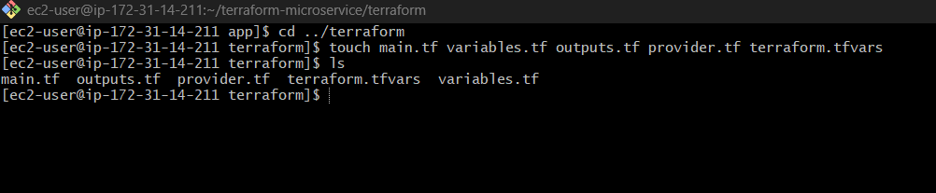
Your structure should look like:
project/
├── terraform/
│ ├── main.tf
│ ├── variables.tf
│ ├── outputs.tf
│ ├── provider.tf
│ └── terraform.tfvars
└── scripts/
└── install.sh

STEP 6: Provider Configuration
Open provider.tf
Open:
vi provider.tf
Paste:
provider "aws" {
region = var.region
}

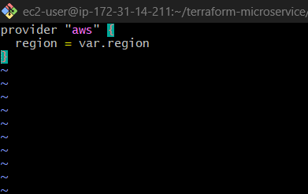

Meaning:
- Terraform will talk to AWS
- Region is not hardcoded → flexible
STEP 7: Variables
Open:
vi variables.tf
Paste:
variable "region" {
default = "ap-south-1"
variable "instance_type" {
default = "t2.micro"
}
variable "key_name" {
description = "EC2 Key Pair Name"
}
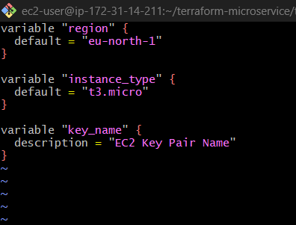

STEP 8: Set Variable Values
Open:
vi terraform.tfvars
Paste:
key_name = "your-keypair-name"
Replace with your actual EC2 key:
Example:
key_name = "my-key"

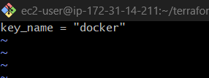

STEP 9: Create ECR Repository
Open:
vi main.tf
Paste:
resource "aws_ecr_repository" "app_repo" {
name = "myapp-repo"
}

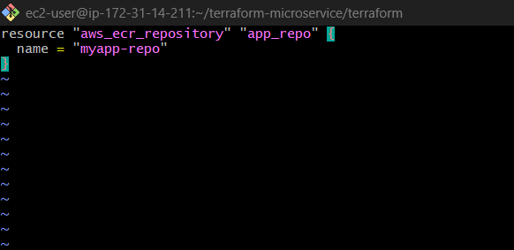

What happens?
- AWS creates private Docker registry

STEP 10: Create VPC + Subnet
( Add to main.tf )

# -------------------------------
# ECR Repository
# -------------------------------
resource "aws_ecr_repository" "app_repo" {
name = "myapp-repo"
}
# -------------------------------
# VPC
# -------------------------------
resource "aws_vpc" "main" {
cidr_block = "10.0.0.0/16"
}
# -------------------------------
# Subnet 1 (Public)
# -------------------------------
resource "aws_subnet" "public" {
vpc_id = aws_vpc.main.id
cidr_block = "10.0.1.0/24"
availability_zone = "ap-south-1a"
map_public_ip_on_launch = true
}
# -------------------------------
# Subnet 2 (Public - REQUIRED FOR ALB)
# -------------------------------
resource "aws_subnet" "public2" {
vpc_id = aws_vpc.main.id
cidr_block = "10.0.2.0/24"
availability_zone = "ap-south-1b"
map_public_ip_on_launch = true
}
# -------------------------------
# Internet Gateway
# -------------------------------
resource "aws_internet_gateway" "gw" {
vpc_id = aws_vpc.main.id
}
# -------------------------------
# Route Table
# -------------------------------
resource "aws_route_table" "rt" {
vpc_id = aws_vpc.main.id
}
resource "aws_route" "route" {
route_table_id = aws_route_table.rt.id
destination_cidr_block = "0.0.0.0/0"
gateway_id = aws_internet_gateway.gw.id
}
resource "aws_route_table_association" "rta1" {
subnet_id = aws_subnet.public.id
route_table_id = aws_route_table.rt.id
}
resource "aws_route_table_association" "rta2" {
subnet_id = aws_subnet.public2.id
route_table_id = aws_route_table.rt.id
}
# -------------------------------
# SECURITY GROUP - Load Balancer
# -------------------------------
resource "aws_security_group" "lb_sg" {
vpc_id = aws_vpc.main.id

ingress {
from_port = 80
to_port = 80
protocol = "tcp"
cidr_blocks = ["0.0.0.0/0"]
}
egress {
from_port = 0
to_port = 0
protocol = "-1"
cidr_blocks = ["0.0.0.0/0"]
}
}
# -------------------------------
# SECURITY GROUP - EC2
# -------------------------------
resource "aws_security_group" "ec2_sg" {
vpc_id = aws_vpc.main.id

# Only LB → EC2
ingress {
from_port = 80
to_port = 80
protocol = "tcp"
security_groups = [aws_security_group.lb_sg.id]
}
# SSH (for testing)
ingress {
from_port = 22
to_port = 22
protocol = "tcp"
cidr_blocks = ["0.0.0.0/0"]
}
egress {
from_port = 0
to_port = 0
protocol = "-1"
cidr_blocks = ["0.0.0.0/0"]
}
}
# -------------------------------
# EC2 INSTANCE
# -------------------------------
resource "aws_instance" "app" {
ami = "ami-0a0823e4ea064404d"
instance_type = var.instance_type
subnet_id = aws_subnet.public.id
key_name = var.key_name
vpc_security_group_ids = [aws_security_group.ec2_sg.id]
user_data = file("../scripts/install.sh")
tags = {
Name = "DevOps-App"
}
}
# -------------------------------
# LOAD BALANCER (FIXED)
# -------------------------------
resource "aws_lb" "app_lb" {
name = "app-lb"
load_balancer_type = "application"
subnets = [
aws_subnet.public.id,
aws_subnet.public2.id
]

security_groups = [aws_security_group.lb_sg.id]
}
# -------------------------------
# TARGET GROUP
# -------------------------------
resource "aws_lb_target_group" "tg" {
port = 80
protocol = "HTTP"
vpc_id = aws_vpc.main.id
}
# -------------------------------
# ATTACH EC2
# -------------------------------
resource "aws_lb_target_group_attachment" "attach" {
target_group_arn = aws_lb_target_group.tg.arn
target_id = aws_instance.app.id
port = 80
}
# -------------------------------
# LISTENER
# -------------------------------
resource "aws_lb_listener" "listener" {
load_balancer_arn = aws_lb.app_lb.arn
port = 80
protocol = "HTTP"
default_action {
type = "forward"
target_group_arn = aws_lb_target_group.tg.arn
}
}
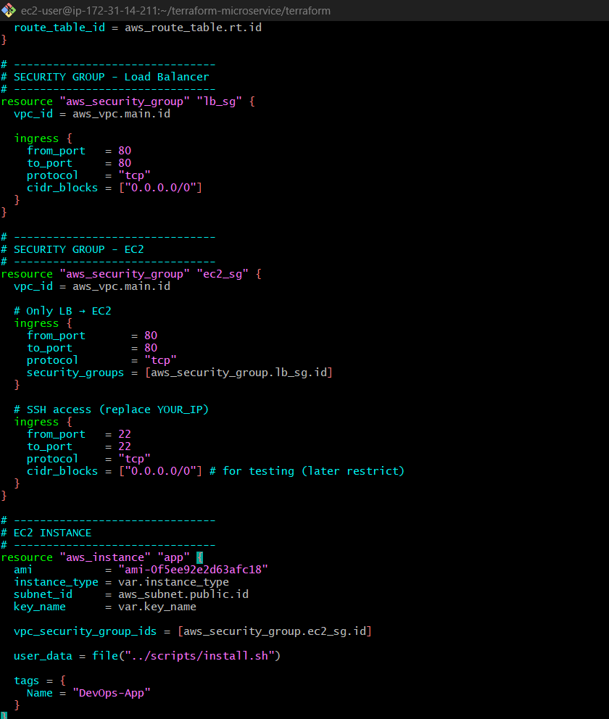

What happens?
- EC2 launches
- Automatically runs script

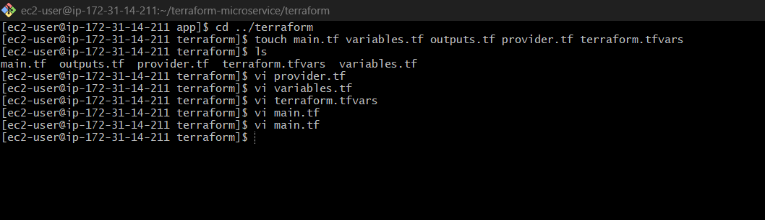

STEP 11: User Data Script
Go to:
cd ../scripts

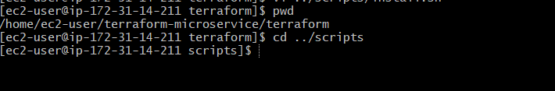

Create file:
vi install.sh

#!/bin/bash
# -------------------------------
# System Update
# -------------------------------
dnf update -y
# -------------------------------
# Install Docker
# -------------------------------
dnf install -y docker
# Start & Enable Docker
systemctl start docker
systemctl enable docker
# Add ec2-user to docker group
usermod -aG docker ec2-user
# -------------------------------
# Install AWS CLI (if needed)
# -------------------------------
dnf install -y aws-cli
# -------------------------------
# Login to ECR
# -------------------------------
aws ecr get-login-password --region us-east-2 | docker login --username AWS --password-stdin 838987715582.dkr.ecr.us-east-2.amazonaws.com
# -------------------------------
# Pull latest image
# -------------------------------
docker pull 838987715582.dkr.ecr.us-east-2.amazonaws.com/myapp-repo:latest
# -------------------------------
# Stop old containers (if any)
# -------------------------------
docker stop $(docker ps -q) || true
docker rm $(docker ps -aq) || true
# -------------------------------
# Run container
# -------------------------------
docker run -d -p 80:80 --name myapp 838987715582.dkr.ecr.us-east-2.amazonaws.com/myapp-repo:latest

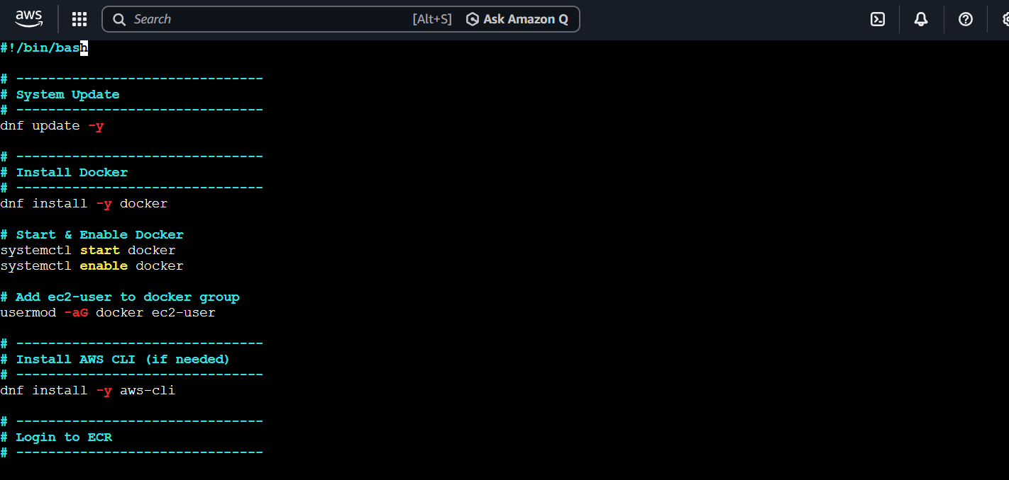

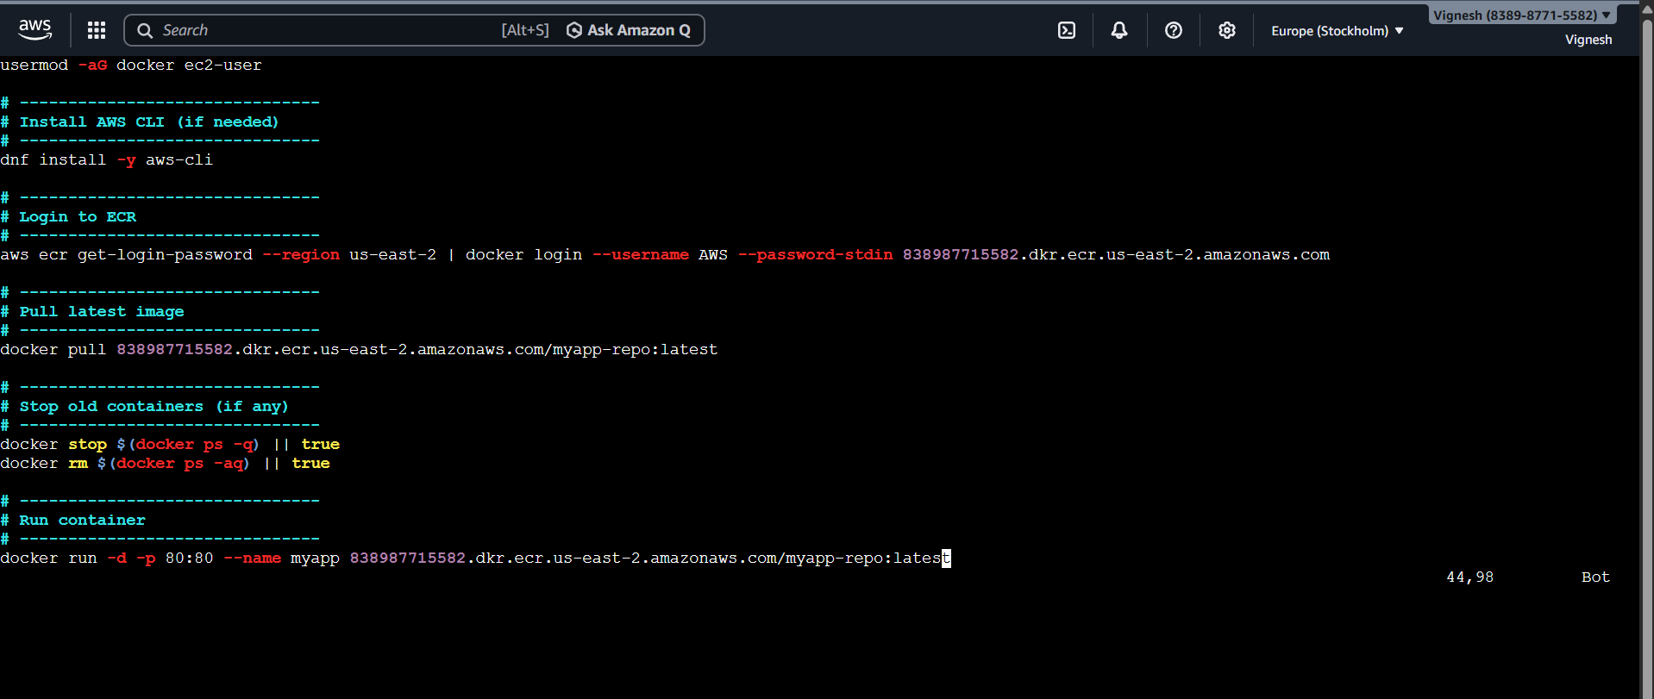

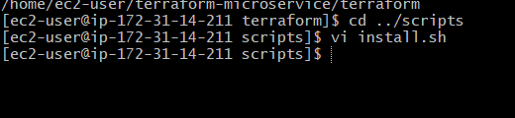

Give permission
chmod +x install.sh

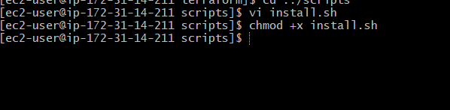

Meaning:
- EC2 auto installs Docker
- Pulls your app
- Runs it
No manual login needed
✅ Amazon Linux 2023
✅ ECR (us-east-2)
✅ Docker install
✅ Auto container run
✅ Clean & production-ready

STEP 12: Load Balancer To (main.tf)

resource "aws_lb" "app_lb" {
name = "app-lb"
load_balancer_type = "application"
subnets = [aws_subnet.public.id]
security_groups = [aws_security_group.lb_sg.id]
}

🎯 Target Group
resource "aws_lb_target_group" "tg" {
port = 80
protocol = "HTTP"
vpc_id = aws_vpc.main.id
}

🔗 Attach EC2 to LB
resource "aws_lb_target_group_attachment" "attach" {
target_group_arn = aws_lb_target_group.tg.arn
target_id = aws_instance.app.id
port = 80
}

🎧 Listener
resource "aws_lb_listener" "listener" {
load_balancer_arn = aws_lb.app_lb.arn
port = 80
protocol = "HTTP"
default_action {
type = "forward"
target_group_arn = aws_lb_target_group.tg.arn
}
}

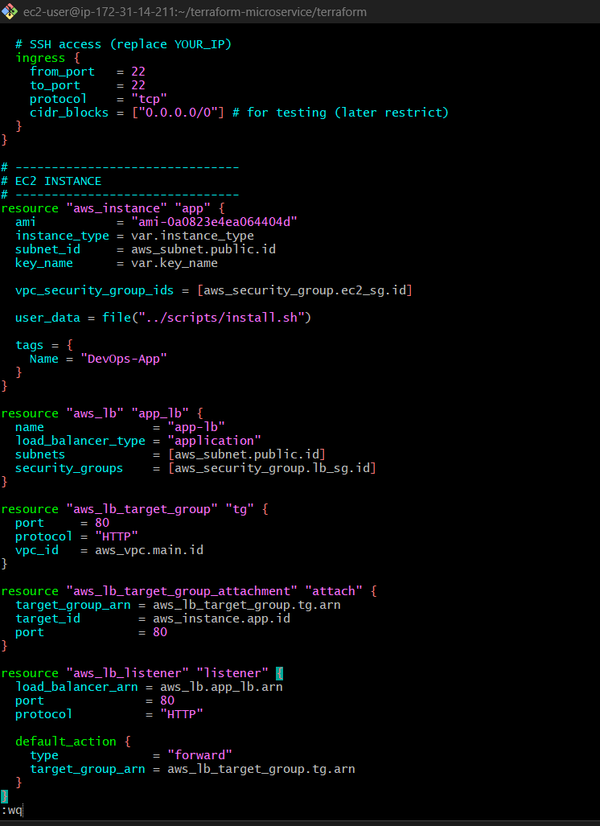
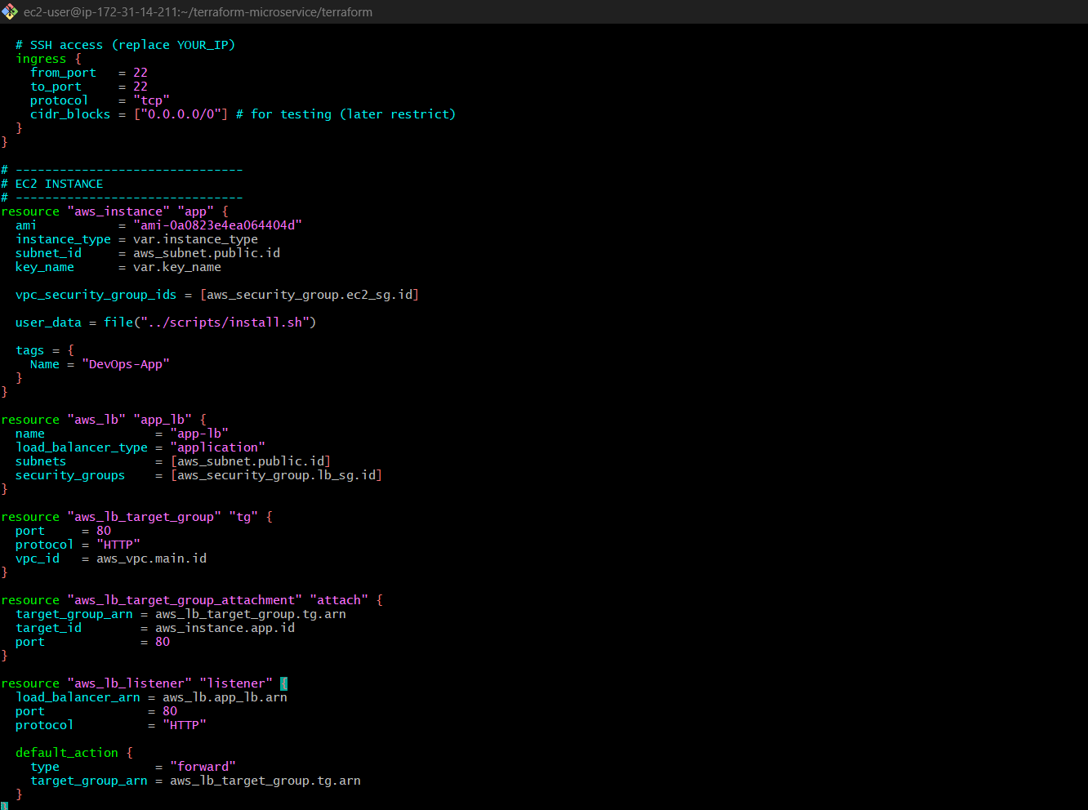

Complete main.tf Code

# -------------------------------
# ECR Repository
# -------------------------------
resource "aws_ecr_repository" "app_repo" {
name = "myapp-repo"
}
# -------------------------------
# VPC
# -------------------------------
resource "aws_vpc" "main" {
cidr_block = "10.0.0.0/16"
}
# -------------------------------
# Subnets (PUBLIC - 2 AZs REQUIRED FOR ALB)
# -------------------------------
resource "aws_subnet" "public" {
vpc_id = aws_vpc.main.id
cidr_block = "10.0.1.0/24"
availability_zone = "eu-north-1a"
map_public_ip_on_launch = true
}
resource "aws_subnet" "public2" {
vpc_id = aws_vpc.main.id
cidr_block = "10.0.2.0/24"
availability_zone = "eu-north-1b"
map_public_ip_on_launch = true
}
# -------------------------------
# Internet Gateway
# -------------------------------
resource "aws_internet_gateway" "gw" {
vpc_id = aws_vpc.main.id
}
# -------------------------------
# Route Table
# -------------------------------
resource "aws_route_table" "rt" {
vpc_id = aws_vpc.main.id
}
resource "aws_route" "route" {
route_table_id = aws_route_table.rt.id
destination_cidr_block = "0.0.0.0/0"
gateway_id = aws_internet_gateway.gw.id
}
resource "aws_route_table_association" "rta1" {
subnet_id = aws_subnet.public.id
route_table_id = aws_route_table.rt.id
}
resource "aws_route_table_association" "rta2" {
subnet_id = aws_subnet.public2.id
route_table_id = aws_route_table.rt.id
}
# -------------------------------
# SECURITY GROUP - Load Balancer
# -------------------------------
resource "aws_security_group" "lb_sg" {
vpc_id = aws_vpc.main.id
ingress {
from_port = 80
to_port = 80
protocol = "tcp"
cidr_blocks = ["0.0.0.0/0"]
}
egress {
from_port = 0
to_port = 0
protocol = "-1"
cidr_blocks = ["0.0.0.0/0"]
}
}
# -------------------------------
# SECURITY GROUP - EC2
# -------------------------------
resource "aws_security_group" "ec2_sg" {
vpc_id = aws_vpc.main.id
ingress {
from_port = 80
to_port = 80
protocol = "tcp"
security_groups = [aws_security_group.lb_sg.id]
}
ingress {
from_port = 22
to_port = 22
protocol = "tcp"
cidr_blocks = ["0.0.0.0/0"]
}
egress {
from_port = 0
to_port = 0
protocol = "-1"
cidr_blocks = ["0.0.0.0/0"]
}
}
# -------------------------------
# IAM ROLE FOR EC2 (🔥 IMPORTANT)
# -------------------------------
resource "aws_iam_role" "ec2_role" {
name = "ec2-ecr-role"
assume_role_policy = jsonencode({
Version = "2012-10-17"
Statement = [{
Effect = "Allow"
Principal = {
Service = "ec2.amazonaws.com"
}
Action = "sts:AssumeRole"
}]
})
}
resource "aws_iam_role_policy_attachment" "ecr_read" {
role = aws_iam_role.ec2_role.name
policy_arn = "arn:aws:iam::aws:policy/AmazonEC2ContainerRegistryReadOnly"
}
resource "aws_iam_instance_profile" "ec2_profile" {
name = "ec2-ecr-profile"
role = aws_iam_role.ec2_role.name
}
# -------------------------------
# EC2 INSTANCE
# -------------------------------
resource "aws_instance" "app" {
ami = "ami-0a0823e4ea064404d"
instance_type = var.instance_type
subnet_id = aws_subnet.public.id
key_name = var.key_name
vpc_security_group_ids = [aws_security_group.ec2_sg.id]
iam_instance_profile = aws_iam_instance_profile.ec2_profile.name
user_data = file("../scripts/install.sh")
tags = {
Name = "DevOps-App"
}
}
# -------------------------------
# LOAD BALANCER
# -------------------------------
resource "aws_lb" "app_lb" {
name = "app-lb"
load_balancer_type = "application"
subnets = [
aws_subnet.public.id,
aws_subnet.public2.id
]
security_groups = [aws_security_group.lb_sg.id]
}
# -------------------------------
# TARGET GROUP
# -------------------------------
resource "aws_lb_target_group" "tg" {
port = 80
protocol = "HTTP"
vpc_id = aws_vpc.main.id
}
# -------------------------------
# ATTACH EC2
# -------------------------------
resource "aws_lb_target_group_attachment" "attach" {
target_group_arn = aws_lb_target_group.tg.arn
target_id = aws_instance.app.id
port = 80
}
# -------------------------------
# LISTENER
# -------------------------------
resource "aws_lb_listener" "listener" {
load_balancer_arn = aws_lb.app_lb.arn
port = 80
protocol = "HTTP"
default_action {
type = "forward"
target_group_arn = aws_lb_target_group.tg.arn
}
}

✅ Added IAM Role (ECR access)
✅ Attached Instance Profile
✅ Fixed AZ → eu-north-1
✅ Ensured ALB uses 2 subnets
✅ Clean structure (production style)

STEP 13: Outputs (SEPARATE FILE)
Put this in outputs.tf
output "lb_dns" {
value = aws_lb.app_lb.dns_name
}

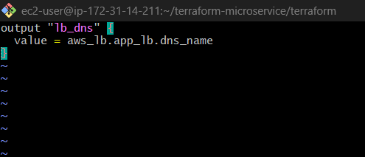
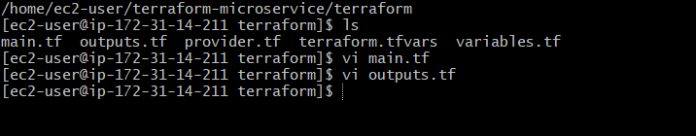

STEP 14: Key Pair
Run:
ssh-keygen -t rsa
Then:
- Go AWS Console → EC2 → Key Pairs
- Import .pub key

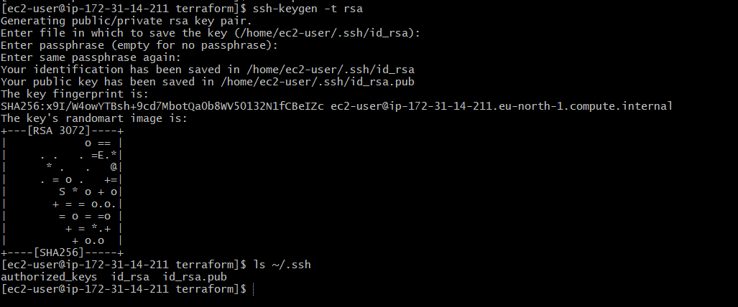

Since you are here:
/home/ec2-user/terraform-microservice/terraform
Just run:
ssh-keygen -t rsa

WHAT WILL HAPPEN
You’ll see prompts like:
Enter file in which to save the key (/home/ec2-user/.ssh/id_rsa):
Just press Enter
Then:
Enter passphrase:
Press Enter (skip)

RESULT
Keys will be created here:
~/.ssh/
Check:
ls ~/.ssh
You’ll see:
id_rsa (private key)
id_rsa.pub (public key)

STEP 15: Upload Public Key to AWS
Now copy public key:
cat ~/.ssh/id_rsa.pub
Copy full output
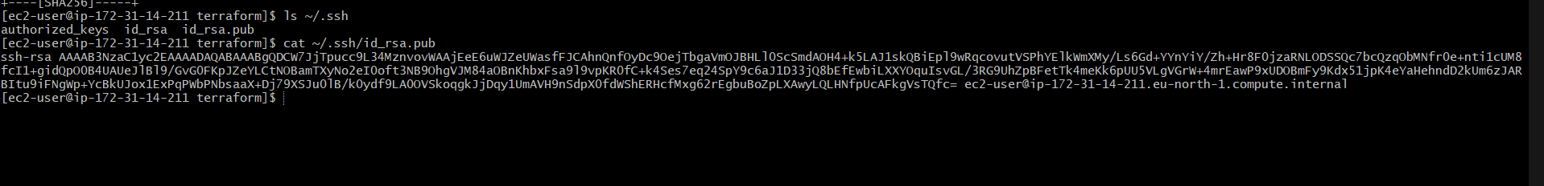

STEP-BY-STEP (CRYSTAL CLEAR)
STEP 1: Copy Your Public Key
Run this in your EC2 terminal:
cat ~/.ssh/id_rsa.pub
You’ll see something like:
ssh-rsa AAAAB3NzaC1yc2EAAAADAQABAAABAQC... ec2-user@ip-172-31-14-211
Copy the FULL line (very important)

STEP 2: Open AWS Console
- Go to 👉 https://console.aws.amazon.com
- Login

STEP 3: Go to EC2 Dashboard
- Search EC2 in search bar
- Click EC2

STEP 4: Open Key Pairs Section
On left side menu:
Click “Key Pairs”

STEP 5: Import Key Pair
Click button:
“Import key pair”

STEP 6: Fill Details
You’ll see a form:
🔹 Key pair name
my-key
Must match Terraform later

🔹 Key pair type
Keep default: RSA

🔹 Public key contents
Paste what you copied:
ssh-rsa AAAAB3NzaC1yc2EAAAADAQABAAABAQC...

STEP 7: Click Import
Click “Import key pair”
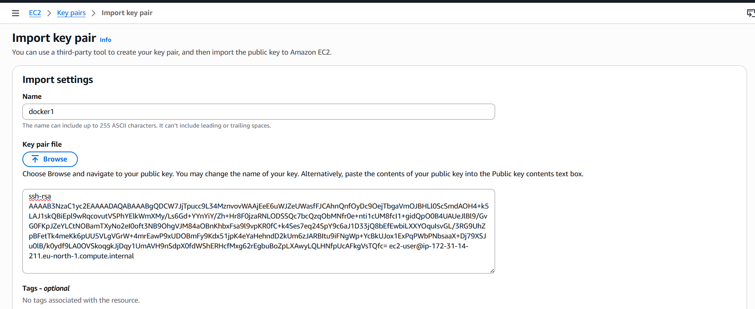

DONE
Now AWS has your key

CONNECT WITH TERRAFORM
Open:
vi terraform.tfvars
Add:
key_name = "my-key"
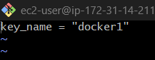

HOW THIS WORKS
When Terraform creates EC2:
AWS injects your public key into the instance
Your private key (id_rsa) is used to login

HOW YOU WILL LOGIN LATER
ssh -i ~/.ssh/id_rsa ec2-user@<EC2-IP>

STEP 16: Terraform Commands
terraform init
terraform plan
terraform apply
STEP 16: Terraform Commands (Final Execution)
Make sure you are inside:
cd ~/terraform-microservice/terraform
Check files:
ls
You should see:
main.tf variables.tf outputs.tf provider.tf terraform.tfvars

1️⃣ Initialize Terraform
terraform init
What happens:
- Downloads AWS provider
- Prepares Terraform working directory
You should see:
Terraform has been successfully initialized!
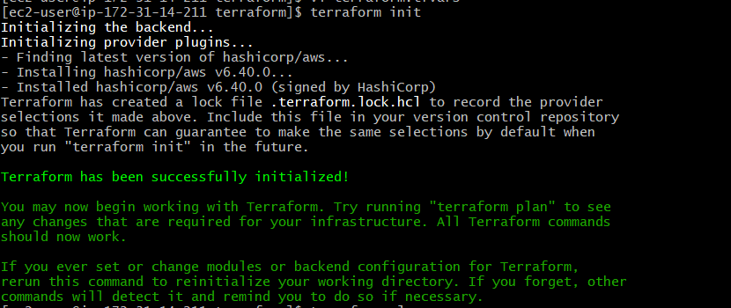

2️⃣ Plan (VERY IMPORTANT)
terraform plan
What happens:
- Shows what Terraform will create
You should see:
+ aws_instance
+ aws_lb
+ aws_security_group
+ aws_ecr_repository
If any error comes → stop and fix before apply

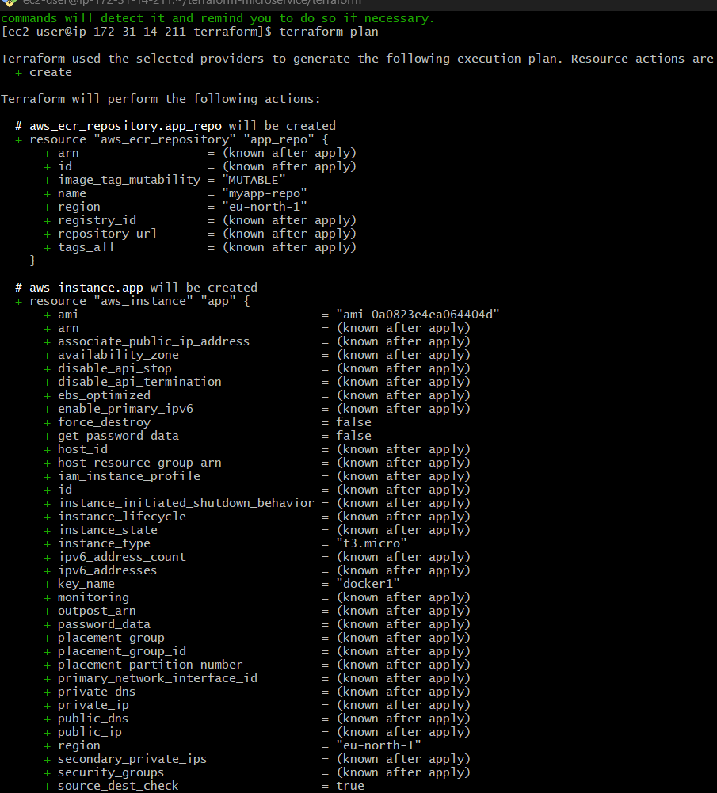
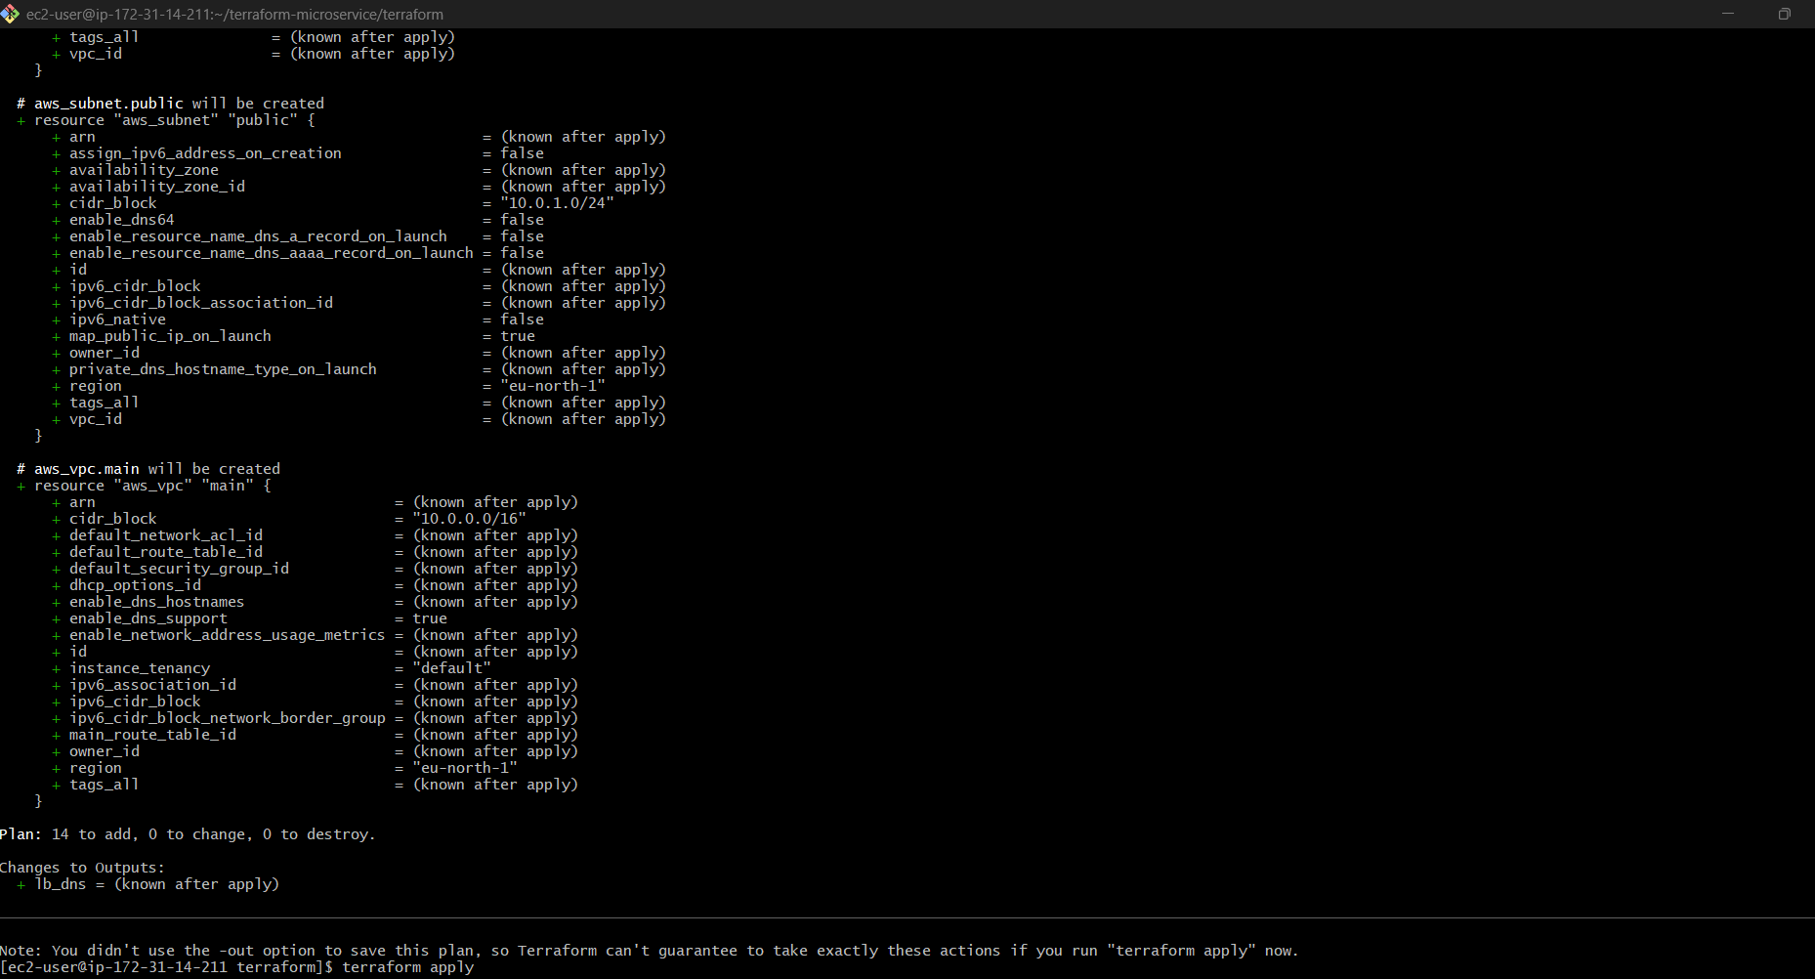

3️⃣ Apply (ACTUAL DEPLOYMENT)
terraform apply
It will ask:
Do you want to perform these actions?
Type:
Yes

WHAT WILL HAPPEN NOW
Terraform will automatically:

✅ Create VPC
✅ Create Subnet
✅ Create Security Groups
✅ Launch EC2
✅ Run install.sh (Docker setup)
✅ Create Load Balancer
✅ Attach EC2 to LB
✅ Create ECR

FINAL OUTPUT
After success, you’ll see:
Outputs:
lb_dns = "app-lb-xxxxx.ap-south-1.elb.amazonaws.com"
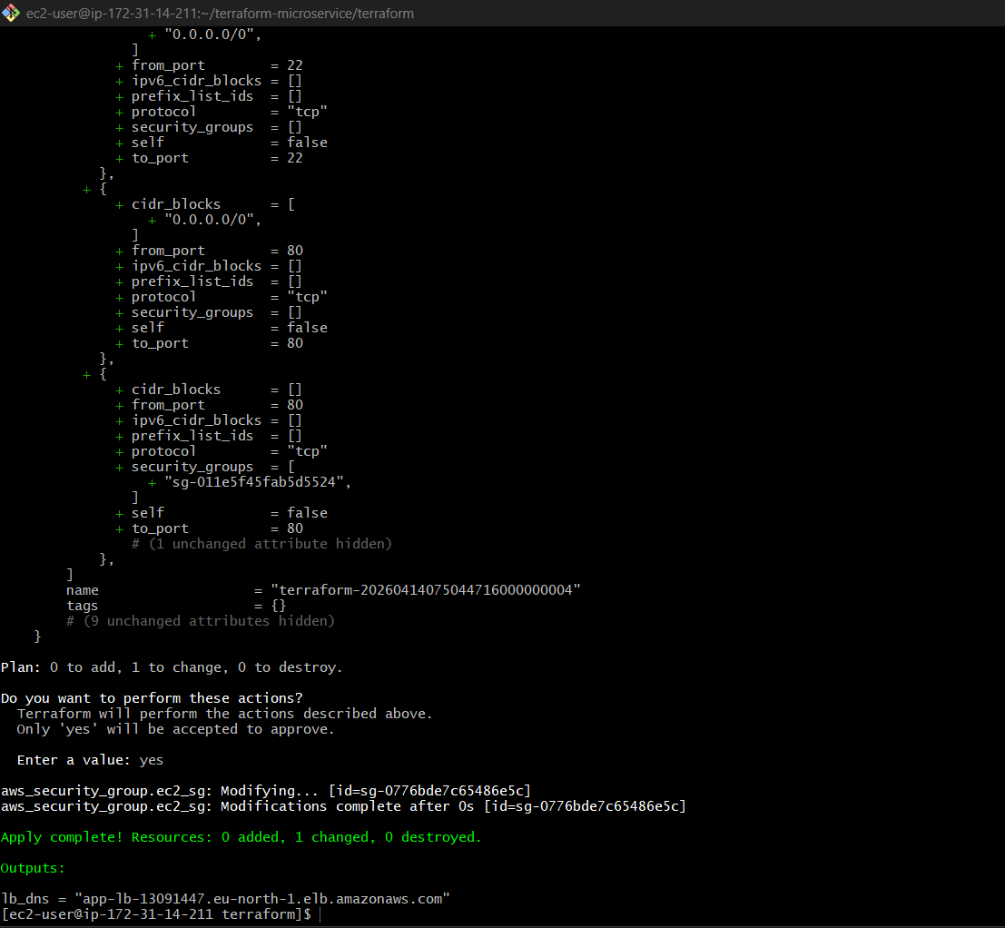

OPEN THIS IN BROWSER
http://<lb_dns>
app-lb-1439969240.eu-north-1.elb.amazonaws.com

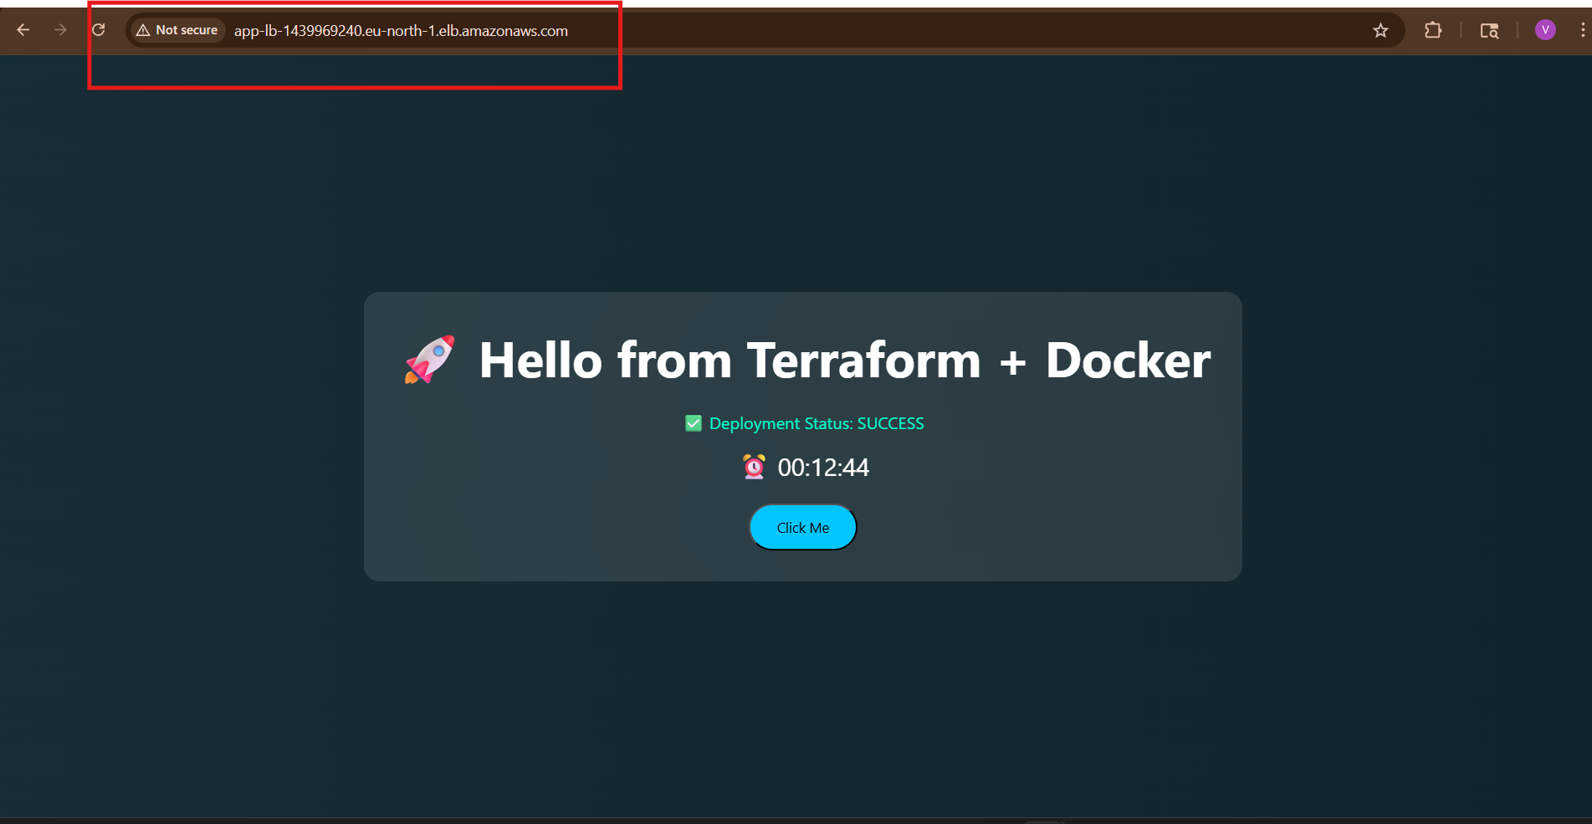
You should see:
Hello from Terraform + Docker
STEP 17: Push Image to ECR
Login:
aws ecr get-login-password --region eu-north-1 | sudo docker login --username AWS --password-stdin 838987715582.dkr.ecr.eu-north-1.amazonaws.com
Tag:
sudo docker tag myapp:latest 838987715582.dkr.ecr.eu-north-1.amazonaws.com/myapp-repo:latest
Push:
sudo docker push 838987715582.dkr.ecr.eu-north-1.amazonaws.com/myapp-repo:latest
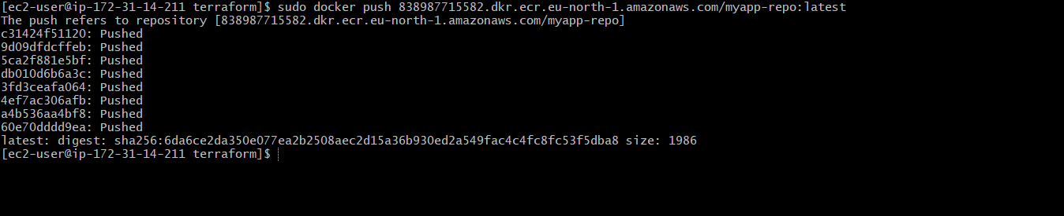

Verify In ECR

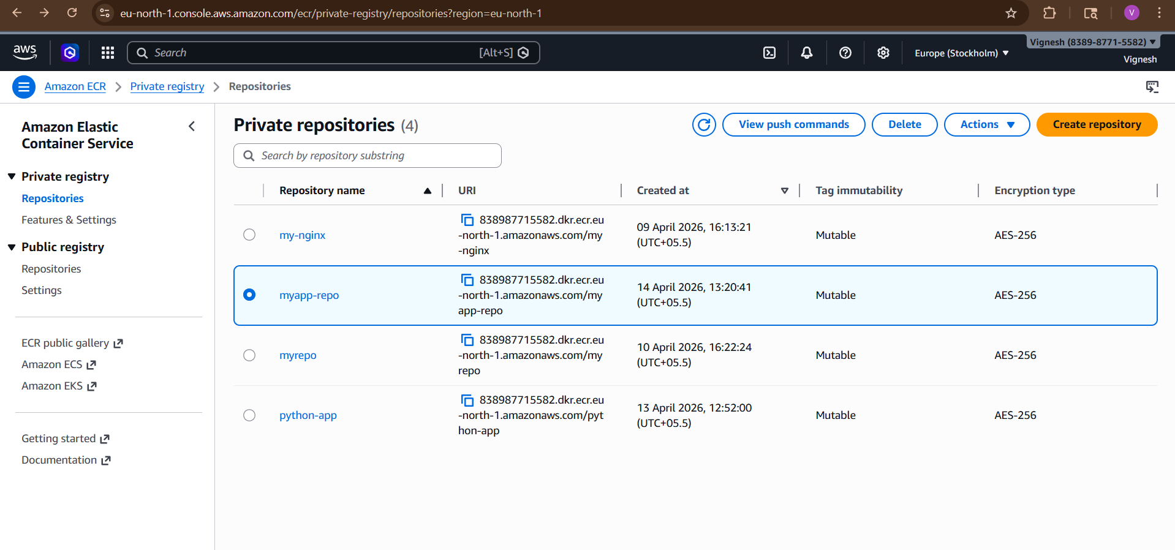

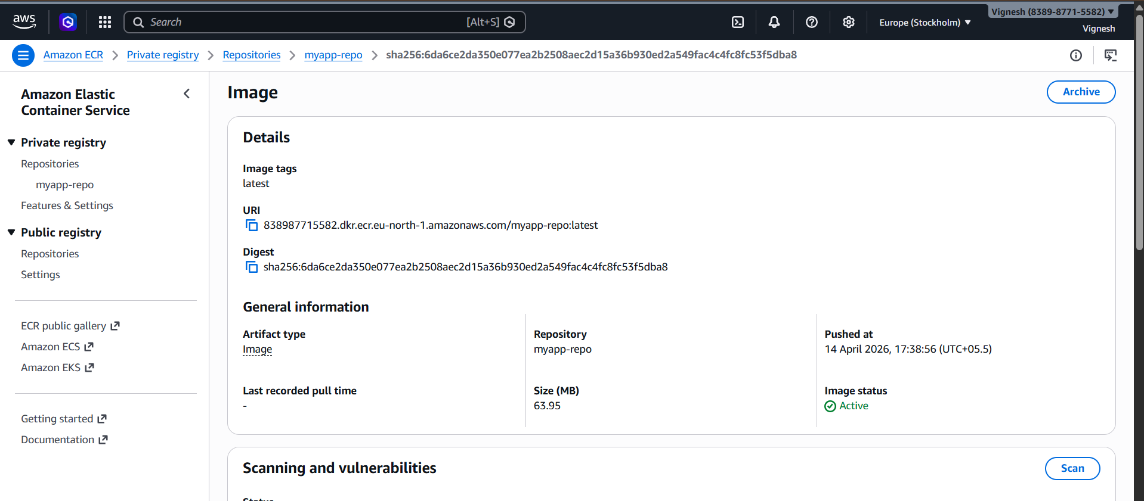

Verify In EC2

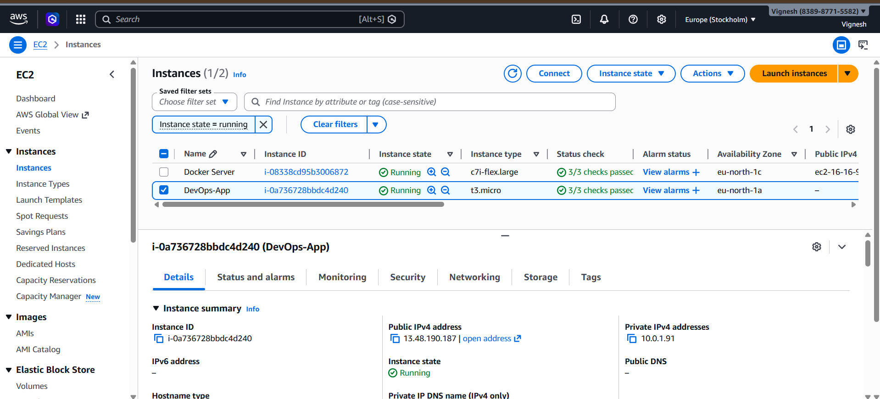

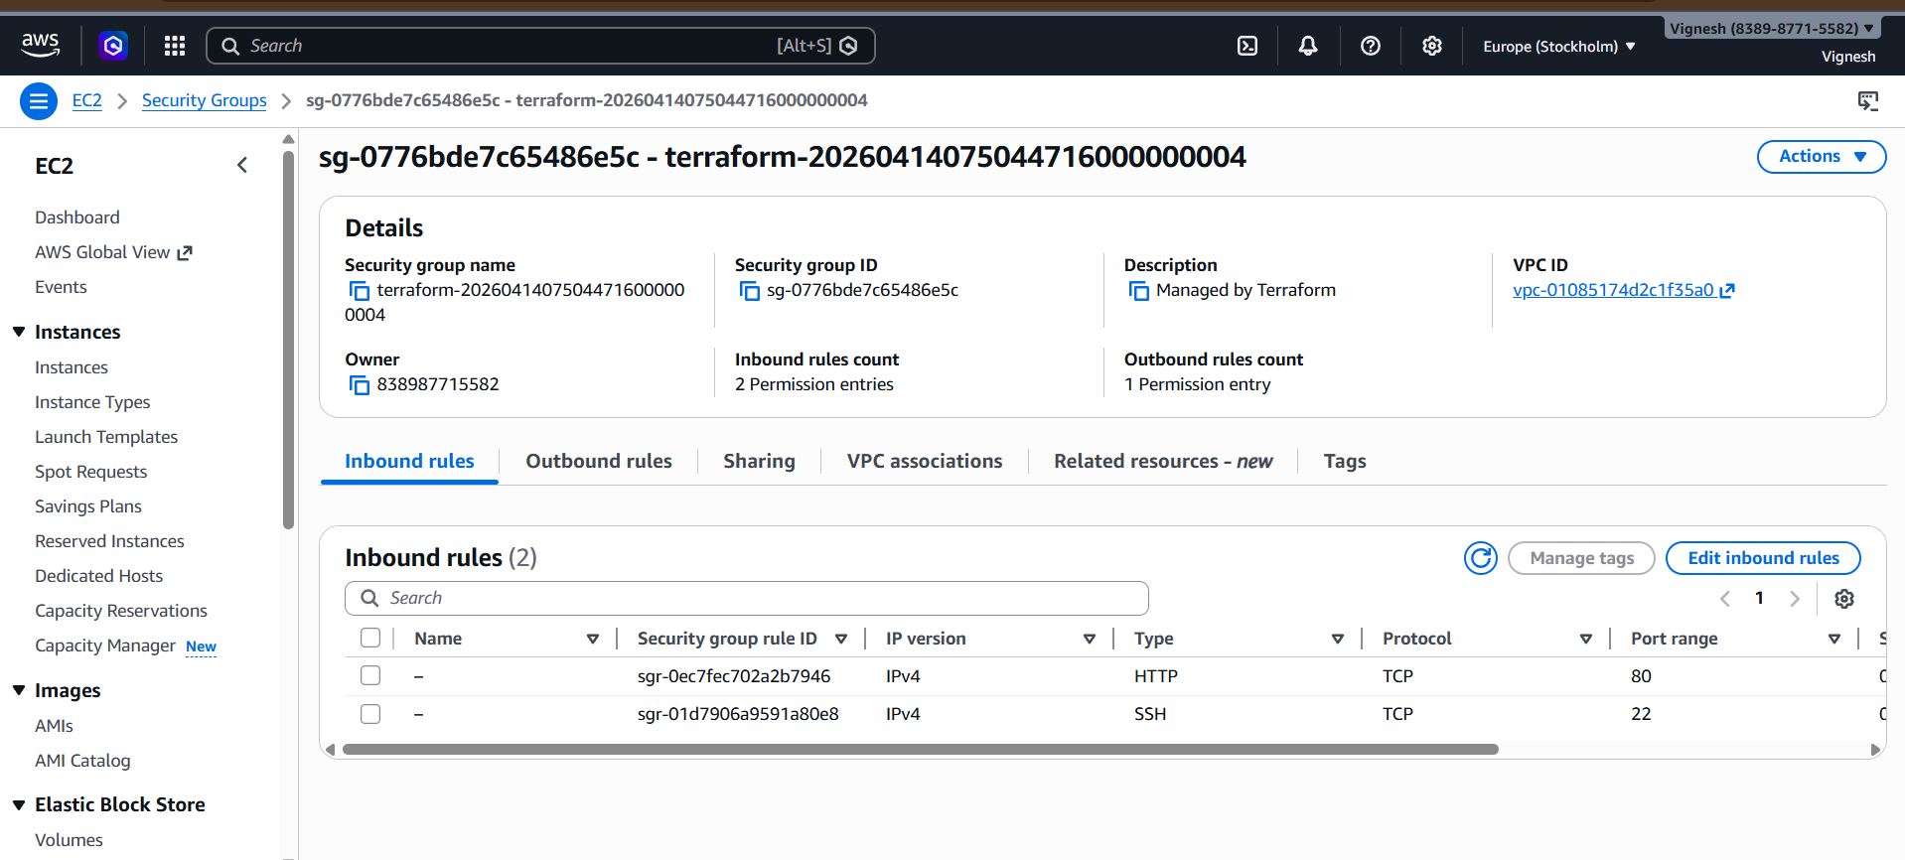

Verify In Load Balancer

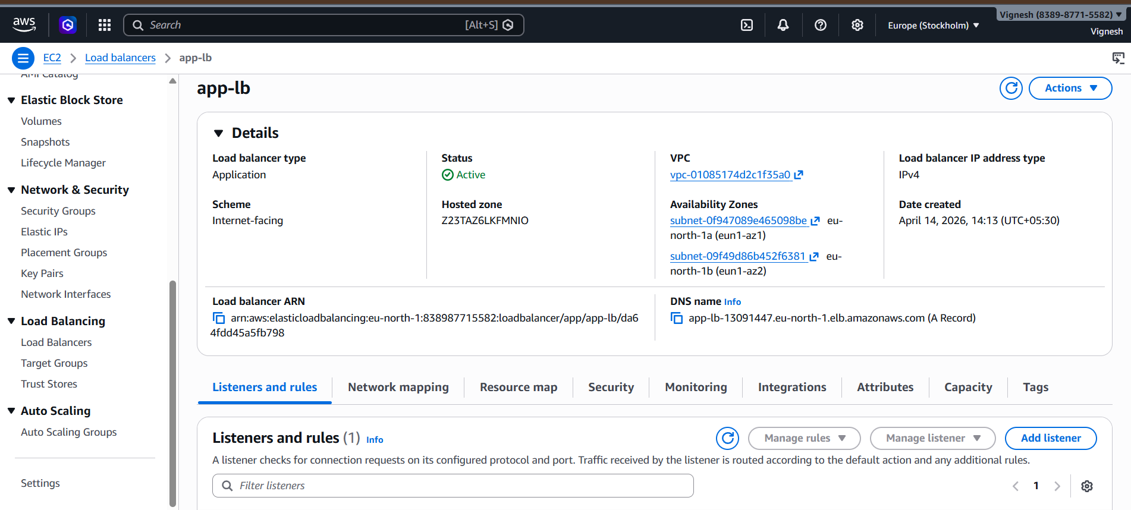

Verify In Target Groups

